The UAW Local 685 Veterans Committee presents:

Veterans Memorial Road Trip
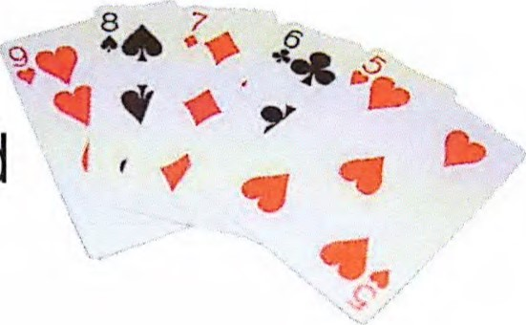
Who: You and your family in your union-made vehicle
What: Collect a poker card at each location to make a hand
When: Sunday, July 17th, 2022
Registration at 8:00am
(Pre-registration available by making payment to Jen Greathouse 765-507-1256 or any Vets Committee member) Trip starts at 9:00am Where:
- Begin at Howard County Veteran's Memorial at Darrough Chapel Park
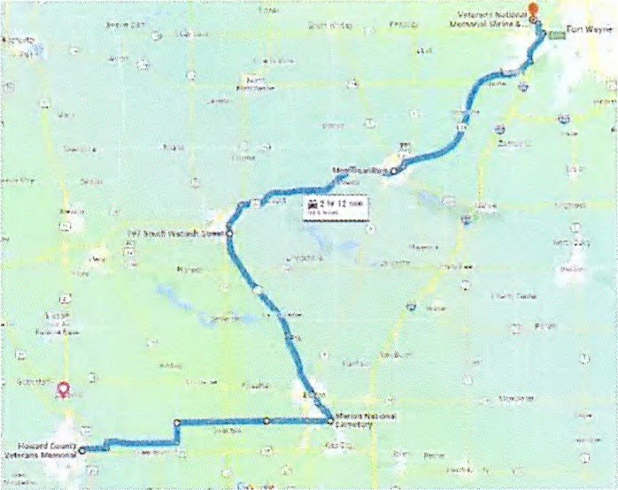
(548 S Goyer Rd, Kokomo, IN 46901)
- Marion National Cemetery
(1700 E 38th st, Marion, IN 46953)
- Wabash County Hero Memorial
(797 S Wabash st, Wabash, IN 46992)
- Memorial Park
(1200 W Park Dr, Huntington, IN 46750)
- Finish at Veterans National Memorial Shrine & Museum
(2212 0'Day Road, Fort Wayne, IN 46818)
Cost: $25 per vehicle (includes 1 hand)
$15 for extra hand
$5 to exchange a card
Lunch donations appreciated.
Prizes will be awarded for the Top 3 hands and Worst hand. Lunch will be served at 12:00pm at the finish location.
kjp-opeiu#l-afl-cio

